Building a 1420MHz Interdigital Band Pass Filter

Introduction

A 1420MHz narrow-band filter is designed using the excellent internet calculator¹ written by D. Heatherington WA4DSY and following construction ideas from the Utah ATV Page².
Here we opted for a 6MHz 0.1dB ripple bandwidth 3-element interdigital filter.

Design

Using the internet calculator, (http://www.wa4dsy.net/cgi-bin/idbpf ).
Prior to clicking the 'Submit Query' button, input data is as shown in Figure 1,

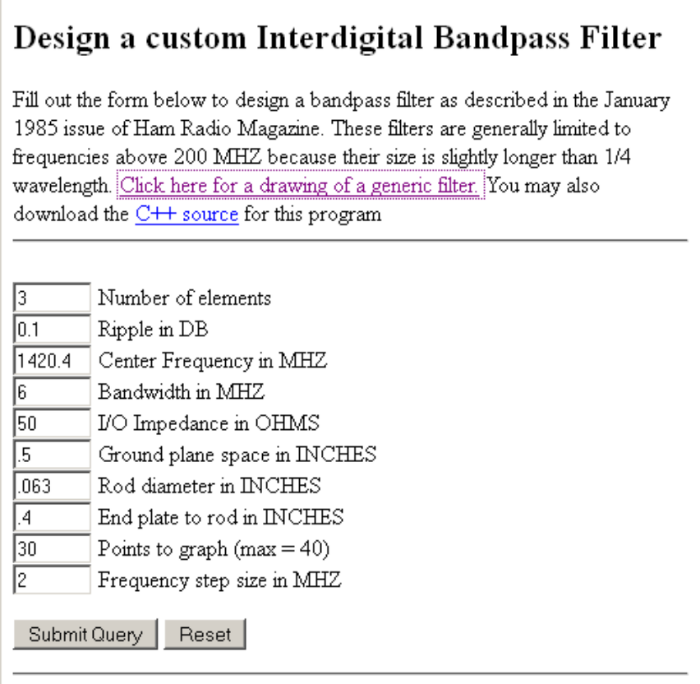

Figure 1. Submit Design Data

The design result is shown in the Appendix. 0.1dB ripple was chosen to ensure a flat band over the chosen bandwidth of 6MHz to completely encompass the H-line band. Copper rod is available on the internet/ebay for a reasonable price although slightly larger 14swg tinned copper wire could also be used. Bronze brazing rod is also a candidate although it is not so easy to lead solder. 0.4" end plate to rod spacing was chosen to allow space for the SMA connector and convenience for soldering to the end rods.

Construction

The basic construction is shown in Figure 2 and uses the design details set out in the Appendix. Figures are given in inches although conversion to millimetres is preferred for better accuracy.

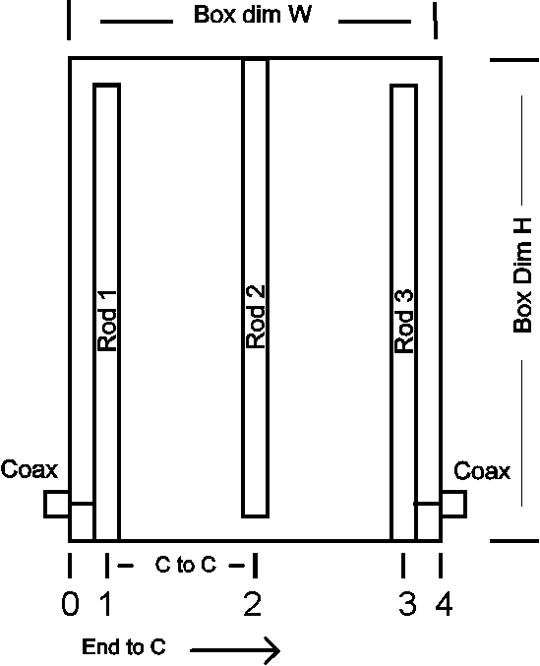

Figure 2. 3-element Narrow Band Interdigital Filter schematic

The box/cavity is constructed using 0.9mm copper plate cut and bent to shape. A paper pattern based on the W and H given sizes is cut out as shown in Figure 3; box height is 0.5".
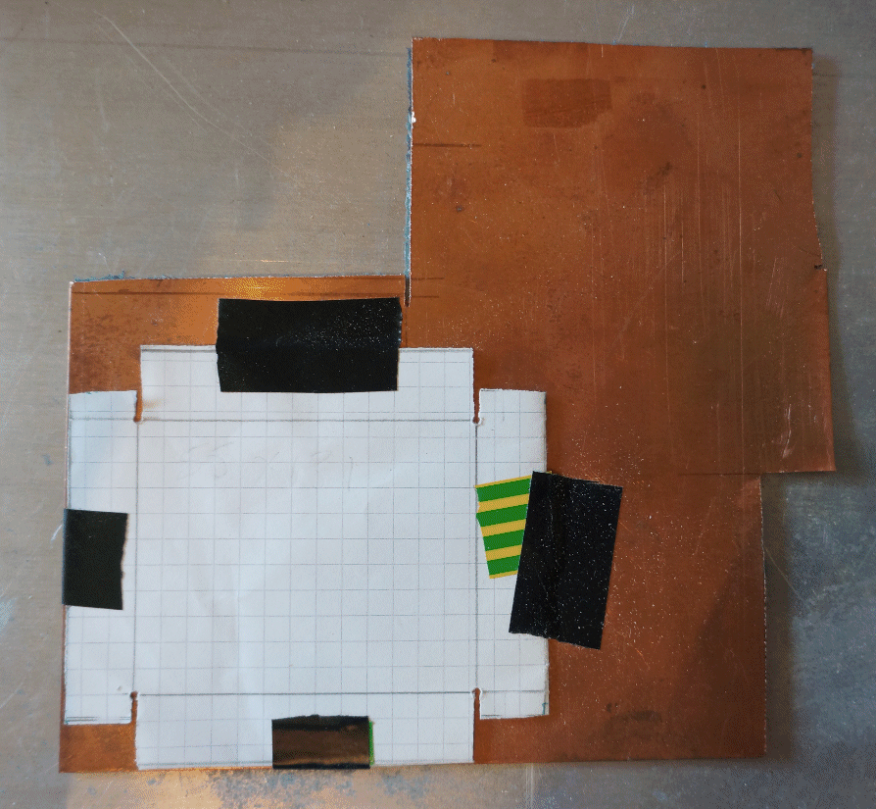

Figure 3. Box/Cavity pattern

The box pattern is taped onto the 0.9mm copper sheet and prior to cutting, the box base corners are drilled with 1mm holes to ease edge bending. Ignoring the tape, the copper sheet can now be carefully cut with a junior hacksaw on the pattern edges as indicated.

Next two wood blocks are cut exactly to the required box inner dimensions (HxW data in Appendix). Hardwood or composites producing a firm sharp edge that is unlikely to compress when the copper is bent around it. Of course, aluminium or other metal blocks would do.

Place the blocks above and below the cut sheet centre and clamp with two G-clamps.
First bend the long edges and tap with a hammer to ensure a sharp bend and flat against the top block.
Then re-position the G-clamps one at a time and bend the shorter sides as before.
When both pairs of sides are satisfactorily flat against the block, the end lugs can be bent and tapped lightly with the hammer to contain the sides (see Figure 4).
The blocks can now be removed. The more difficult the inner block is to remove, the better the cavity accuracy achieved.
A similar construction technique is used for the lid using slightly larger (by 1.8mm) blocks.

The box sides can now be marked and drilled for the rods and connectors.

The next task is to tap the holes required for the screw tuning adjusters. M3 taps and screws with locking nuts are suitable for this.

Rods can be supported in place by suitable small blocks of wood and clamped for soldering and gap adjustment. Soldering the rod ends to the box at the half (0.25") height using a cook's gas blow-torch giving a small controlled flame enables sufficient heat for satisfactory joints.

SMA female connectors (two hole panel mount types) are used for input and output.
The input and output connections to the elements need care to solder as they are about 1mm from the rod (box) end as is evident from Figure 4. If the connecting wire is first soldered to the SMA connector spur, bent as shown, pressing the rod and then soldered, accuracy is improved.

The lid is fitted by removing/filing parts as required (note the modification in Figure 4).

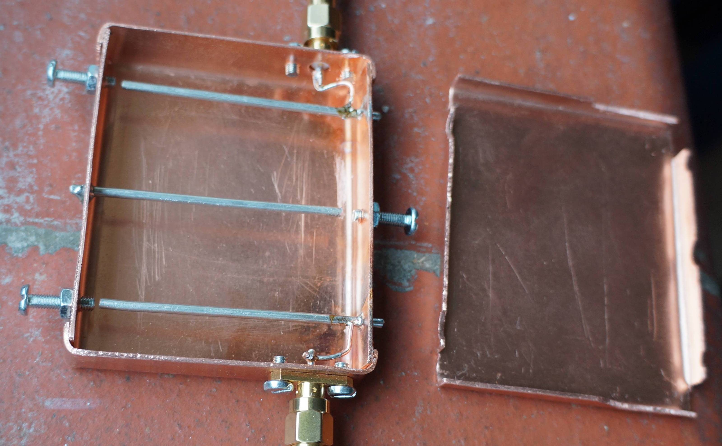
Figure 4. Complete 3-element Narrow Band Interdigital Filter

Tuning

Tuning is relatively easy for a 3-element filter; first you maximise levels by tuning the centre element then by trimming the outer rods using the dongle with SDR# software and monitoring the displayed receiver noise level. By tuning the dongle centre frequency in 1MHz increments either side of 1420MHz the receiver noise amplitude follows the filter characteristic. Performance achieved was 6MHz 0.1dB ripple bandwidth and 16MHz 20dB bandwidth. Initially, this filter tuned 10 MHz low, but by shortening the centre element (obvious as the tuning screw fell out) by holding the rod in pliers whilst trimming with a flat needle file, success can be achieved.
The lid should be sensibly clamped (or if confident, soldered) to ensure stable performance.

References

- http://www.wa4dsy.net/cgi-bin/idbpf
- http://www.ussc.com/~uarc/utah_atv/interdigital1.html

Appendix Design data for 3 section interdigital bandpass filter.
Bandpass ripple = 0.100 DB
Center frequency = 1420.400MHZ
Cutoff frequency = 1417.400 and 1423.400 MHZ
Ripple BW = 6.000 MHZ
3 DB BW = 8.334 MHZ
Fractional BW = 4.224 MHZ
Filter Q = 170.435
Est QU = 1310.986
Loss Based on this QU = 2.516 DB
Delay at band center = 85.163 NS
Freq DB loss
* 1390.4 55.6
* 1392.4 53.8
* 1394.4 51.9
* 1396.4 49.8
* 1398.4 47.5
* 1400.4 45.0
* 1402.4 42.2
* 1404.4 39.1
* 1406.4 35.6
* 1408.4 31.4
* 1410.4 26.5
* 1412.4 20.3
* 1414.4 12.2
* 1416.4 2.3
* 1418.4 0.1
* 1420.4 0.1
* 1422.4 0.1
* 1424.4 2.3
* 1426.4 12.2
* 1428.4 20.3
* 1430.4 26.5
* 1432.4 31.4
* 1434.4 35.6
* 1436.4 39.1
* 1438.4 42.2
* 1440.4 45.0
* 1442.4 47.5
* 1444.4 49.8
* 1446.4 51.9
* 1448.4 53.8

Quarter wavelength = 2.077 inches
Length of interior elements = 1.995 inches
Length of end elements = 1.996 inches
Ground plane space = 0.500 inches
Rod diameter = 0.063 inches

End plates are 0.400 inches from centre of end rod.
Tap external lines up 0.045 inches from shorted end.
Line impedances: End rod: 137.899, other: 138.686 Ext. lines: 50.000 Ohms
Dimensions (inches)
El. No. End to C C to C G[k] Q/Coup
0
1 0.400 0.898 1.032 0.662
2 1.298 0.898 1.147 0.662
3 2.196 - 1.032 1.433
4 2.596

Box inside dimensions: 2.077H x 2.596W x 0.500T inches PWEast May 2014

